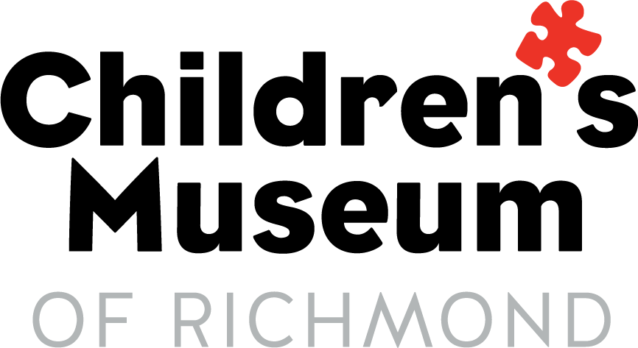
Required COVID‐19 Waiver for Children's Museum of Richmond

- Participants in my group are free from symptoms related to COVID‐19 as defined by the CDC without the aid of medication for the last 14 days.

- Participants in my group have not been in close contact as defined by the CDC with any individual with COVID-19 symptoms or COVID-19 positive test result within the last 14 days, unless the contact was a result of the participant’s duties performed as a medical professional while adhering to all COVID-19 infection prevention practices and guidelines as defined by the CDC and the American Medical Association.

- Participants in my group have not had a positive diagnosis of COVID-19 in the last 14 days.

- Participants in my group have followed both the CDC and Virginia guidelines regarding COVID‐19.

- Participants in my group will follow the additional policies and procedures the Children’s Museum of Richmond has put in place as a result of COVID‐19.

- I understand that an inherent risk of exposure to COVID‐19 exists in any public place where people are present. The specific risks that may be present at the Children’s Museum of Richmond (CMoR) include, but are not limited to the following:
- being around someone with COVID‐19;
- being exposed to COVID‐19 while at CMoR;
- touching a surface at CMoR that may contain COVID‐19 and then contracting the virus;
- becoming sick or making others around me, including my family and friends, sick by exposing them to COVID‐19 that I contracted at CMoR;
- becoming seriously ill or dying from COVID‐19 or its related effects on my body or the bodies of any other Participants for whom I am responsible; and
- missing work, school, or otherwise being unable to work, attend school, attend any other function, or being quarantined for 14 days or longer due to exposure to COVID‐19 while at CMoR.

By visiting CMoR, I voluntarily assume all risks, to myself/group, related to exposure to COVID‐19, waive all negligence claims including costs and expenses that may arise from any act or failure to act of CMoR, and agree to indemnify and hold harmless to fullest extent allowed by law CMoR and any other persons with whom I come in contact while visiting and present at CMoR for any injuries or harm caused by me or any other Participants for which I am responsible or for whom I completed this Waiver.

Responsible Party Name Date

Responsible Party Signature

