PARENT’S DAY
THANKFULLNESS TOSS
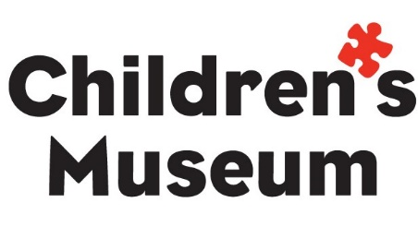
Cut rectangles out on dotted lines and attach them to bottles or cans. Toss a ring toward cans and when it lands on one, read the prompt and answer to your loved one!

Thank you for always giving me _____________________.

I love when we go to __________________ together.

My favorite thing to do outside with you is __________________.

My favorite memory with you is __________________.

Thank you for showing me how to _________________.

My favorite meal to eat with you is _________________.

